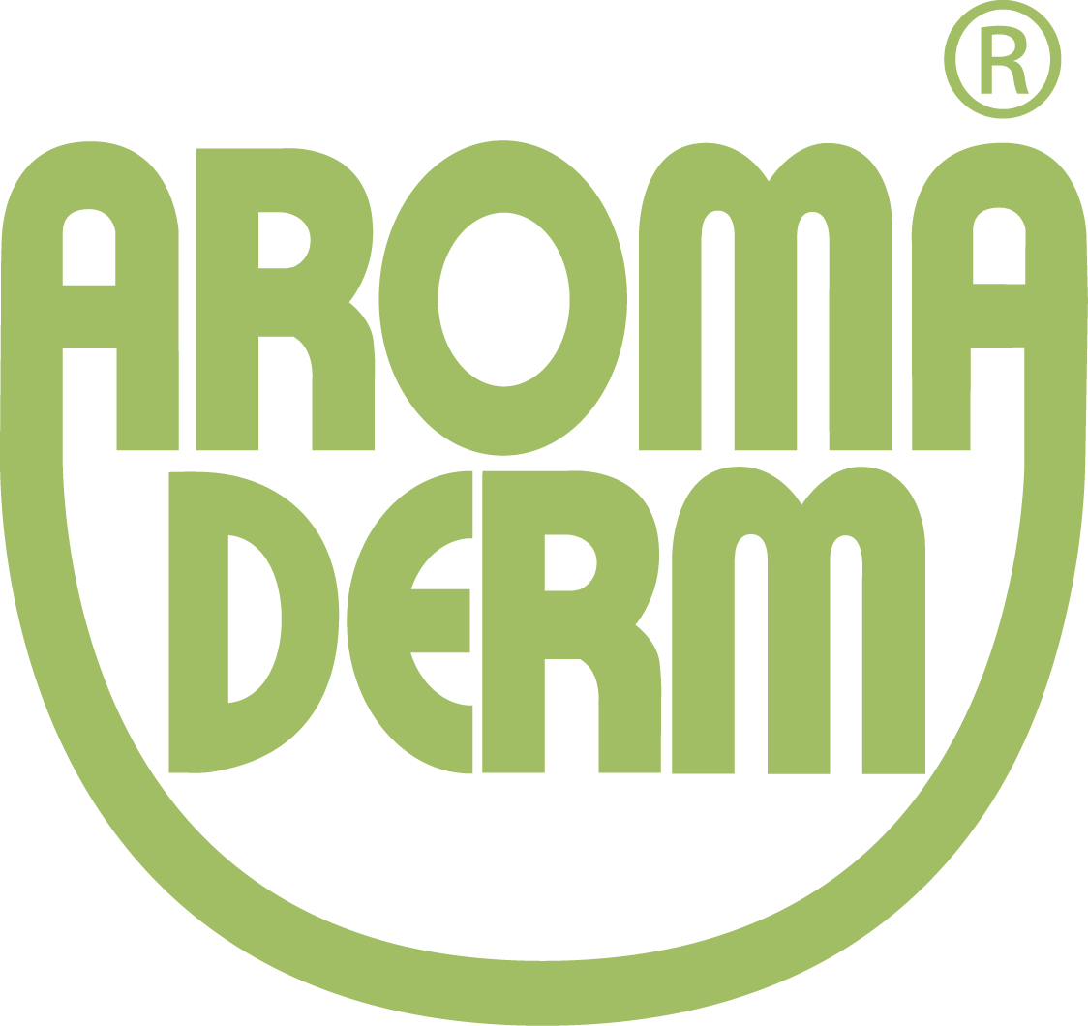

Training Information
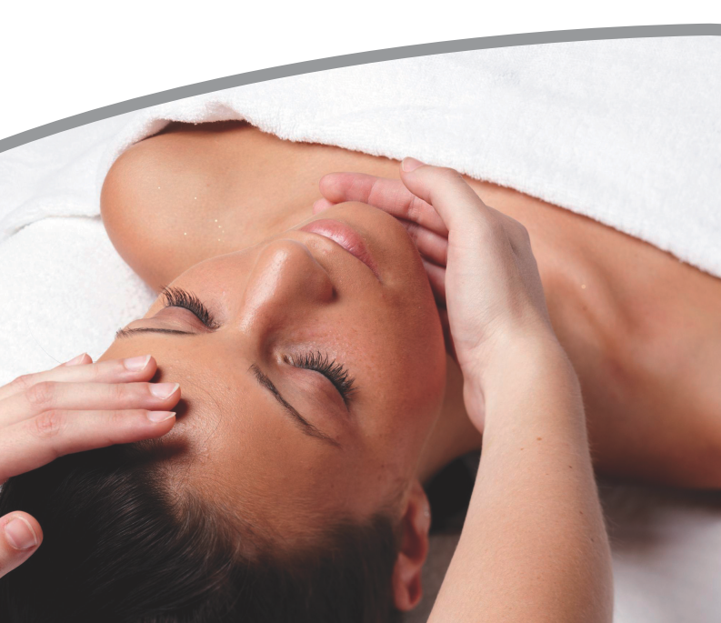
Face Treatments
Face Treatments with success

For the user:

AROMA DERM Face Treatments are highly effective and do what they promise. These natural treatments are easy to use and can be made without a lot of efforts. The essences and systems are perfectly verified on the demands of the treatments and achieve the whished success.
The treatments can be made easily and without any equipment. The natural cosmetic with its valuable essences, oil and herbs is very effective. Affectionately massages with hands give the customer a feeling of total stress relaxation.
If you release all your problems during the rituals, the acceptance of the skin will increase. Because of that the effects of the natural ingredients and essences will be immediately visible.

For the end-consumer:

AROMA DERM Face Treatments are highly effective and do what they promise. No matter for what treatment you decide, the natural essences are for the particular treatment exactly verified. Because of that the whished effect can be aimed through the valuable ingredients of the products. Important is the care after the treatment.
Because the demand of every skin can be covered by suitable products.
Important is the care after the treatment, that the demand of the skin is covered. Trust on the advice of our best trained beautician.

Overview of treatments

Basic Pure Asiatica
Basic Cleansing Treatment for dry skin - for ladies and gentlemen. ~ 60 Min.
For all types of skin with dry and sensible skin, who want to have the feeling of deep cleansing. This classic and intensive face treatment is powerful and the skin is perfectly cleaned afterwards. And it is the base for additive beauty treatments.

Basic Pure Green Tea
Basic cleaning treatment used for impure and mixed skin for ladies and gentlemen ~ 60 Min.
For all types of skin with impure and mixed skin which wants to have the feeling of deep
cleansing. This classic and intensive face treatment is powerful and the skin is perfectly cleaned afterwards. And it is the base for additive beauty treatments.

Classic Moisture
Classic Face Treatment for dry skin ~ 90 Min.
Persons with dry skin know how uncomfortable dry skin is. Everything tenses and you
have the feeling that you always have to cream their face.
Time for the right treatment and for intensive care. During this treatment moisture will return in the skin and the skin will be pampered with highly effective products.

Classic Balance
Classic Face Treatment
Especially for impure skin ~ 90 Min.
This face treatment is perfect for impure skin, which wants to be cared and pampered. After a sophisticated cleansing and treatment of the irritated parts of the skin care the face with valuable products. This treatment is a intensive and fast help for sensible skin.

Classic Men
Classic Face Treatment for men ~ 75 Min.
Even men have to take care of themselves and need special treatments, which cares the skin. So they feel better and more beautiful. In addition stressed skin needs a special care. Do someting for your skin. With this treatment the needs of your skin were fulfilled. The beautician advises you which care products are the best for you.

Modellage Hydro Intensiv
Intensive - Moisture Treatment with special masks ~ 120 min. (incl. sell training)
One of the most popular and successful face treatments. The skin looks immediately sturdy, firm and beautiful. A tender complexion makes a totally new charisma. After cleansing
best moisturizing products where applied on the skin through a skin massage. The generous applied care products can now be absorbed by the skin easily. Absolutely grate how this treatment works!

Modellage 35+
Special Treatment for sophisticated skin. ~ 120 Min.
For everybody, who wants to look fast young and fresh. After a basic face treatment the skin will be pampered with best care essences and moisture will return into the skin.
Special Anti Aging active ingredients produce the warming effect of the model age, which guarantees a younger and shining look.

Beauty de Luxe
Rejuvenate Face Treatment with modellage + Special Eye Treatment~ 120 Min.
This luxury treatment has an highly moisturizing, regenerating effect and is a visible fountain of youth for the face skin. A amorous smelling face treatment with deep cleansing massage and special eye firming mask and a luxury modellage for face. As an additive will be a perfect hand care with peeling and mask. For everyone who wants to look young and attractive.

Pure Energy
Face Treatment for tired and stressed skin ~ 120 Min.
Our skin is our biggest organ and susceptible for all signs of fatigue, force and stress.
Immediately the skin reacts with a tired complexion and a pale and stressed look. This treatment works against this. The refreshing mask gives pure energy and makes this directly visible.

Cacao Pure Power Power
Treatment with Cacao ~ 90 Min.
Chocolate makes happy and is an absolute important source for the skin. The power treatment is used for tired and weak skin, which needs a „cick“. Intensive care will be given fast and the feeling of the skin is immediately more activated. Ideal for persons, who have a lot of stress and who want to relax.

Beautiful Eyes
Special mask for beautiful eyes ~ 30 Min.
The first signs of wrinkles are visible around the sensible parts of the eyes. Also tired eyes make facial features significant older. .At this rapid effect treatment the smooth and fine skin around the eyes will be tightened and small wrinkles disappears nearly. This treatment can be made during all face treatments. Also great as a cure within 3-5 days.

Push Up
Special Breast Treatment for the thigtening of the breast~ 30 Min.
The intensive breast treatment is used for a tight and cared breast. Made with ampoule, tightening mask and gumming special mask, is it a ideal care for the breast to tighten and lift.

Treatment process Aroma Derm
Fragrance- and Relax Ritual
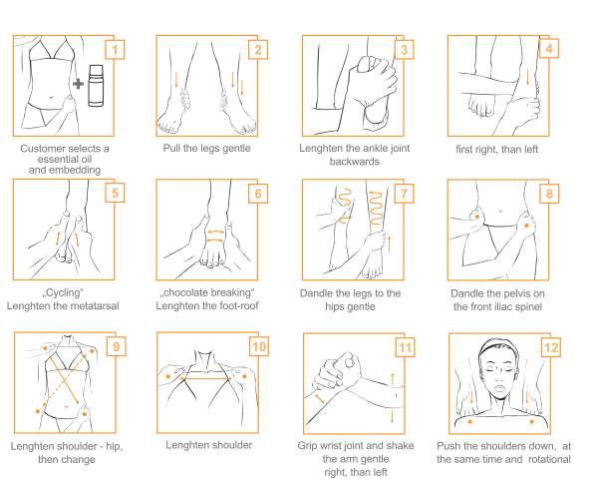
Fragrance Ritual:
1| Select an essential oil and give 3 drops into an aroma lamp (Give Away)

RELAX RITUAL - GREETING:
2| Pull the legs gentle
3-4| Lenghten the ankle joint to the front and backwards, toes a.s.o.
- first to the right, than to the left site
5-6| Metatarsal: cycling, chocolate breaking for lenghtening
7| Dandle the feets and legs to the hip
8| Touch the pelvis on the front iliac hip and dandle it gentle
9| Lenghten the right pelvis with the left shoulder -carefully
- lenghten the lift pelvis with the right shoulder - carefully
10| Touch the shoulder - on both sides - lenghten rotational
11| Touch the right arm on the wrist joint and shake it gently - place your hand on the belly....
- touch the left arm on the wrist joint and shake it gently - place your hand on the belly...
12| Place yourself on the head site; push the shoulders down, rotational left and right
13| Wash your hands
Tip:
f.ex. Cream the feet with goat butter massage cream and place them afterwards into a preheated towel.
for the luxury treatment: Feet washing 120 min.
- 2 table spoons of Rose blossom salt into 1 litre of lukewarm water
- Wash the feet and dry
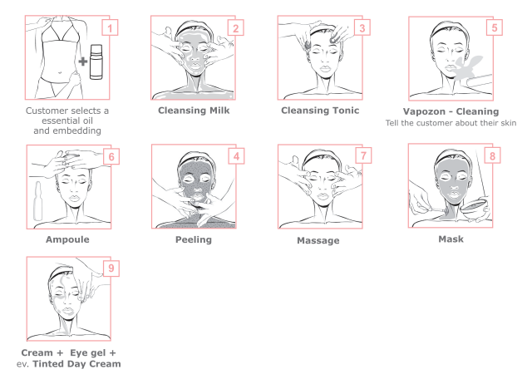
Fragrance Ritual:
1| Select an essential oil and give 3 drops into an aroma lamp (Give Away)

FACE:
2| apply the cleansing milk with warm hands and emulate it with water
- take it away with warm pads
- pat the skin dry with a facial tissue
3| tone with a cotton pad
4| apply the scrub with your hands
5| Steam
- with frimator (if available) scrub and then remove
- deep cleansing - tell the customer about their skin
6| Ampoule (as an additive sale - if it is not usual)
7| Massage
- Remove the massage cream
8| Tap the eye gel into the skin
- Apply the mask with a brush
- Soak the cotton pads with tonic (divide the cotton pads first - then they are lighter for the eyes)
- make the eye treatment - if desired
- put on the cotton pads on the eyes - if desired
- after 10 - 15 minutes remove the mask
9| Finish: Eye gel, (tinted) daycream
(at special treatments - hand peeling + hand massage)
Skin Types
Analyse of the types of skin

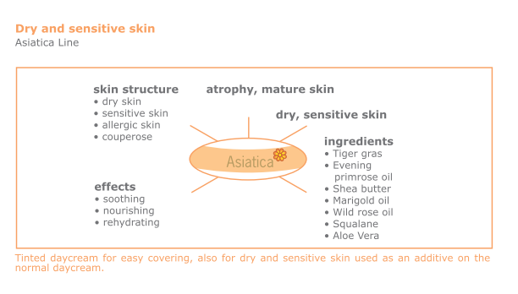

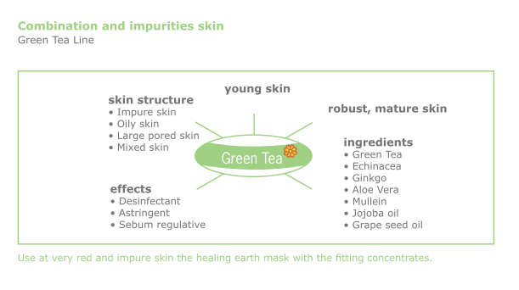
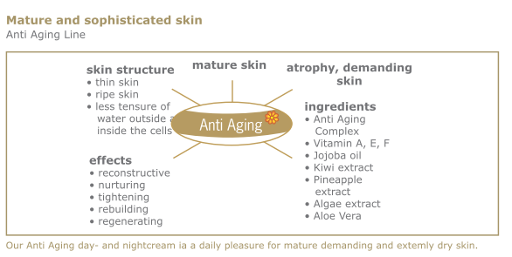

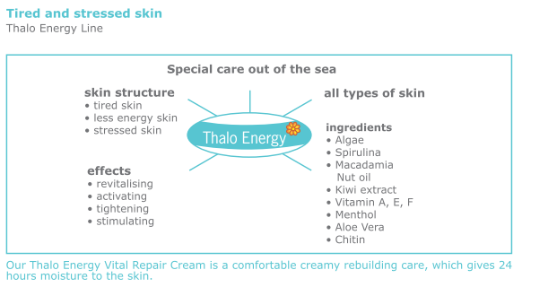
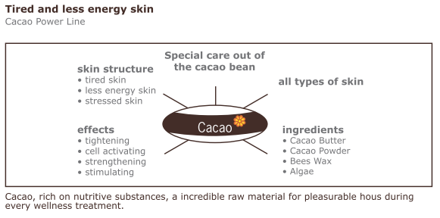

Basic Pure Asiatica ~ 60 Min.
Basic Cleansing Treatment for ladies and gentlemen

Dry and sensitive skin: Asiatica products
Effect: tightening, rehydrating, activating

1. Fragrance Ritual: Choose an essential oil
2. Treatment process
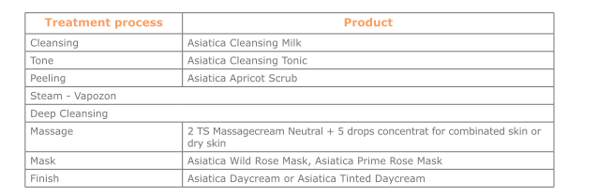

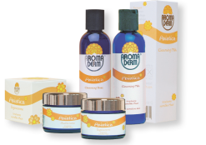
Asiatica products: Main ingredient - Centella Asiatica/Tigergras
Effect: rehydrating, tightening, cell activating

Tip:
Tinted day cream to cover easily for dry and sensible skin, apply on the normal day care.
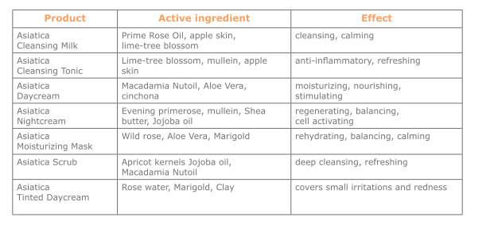

Basic Pure Green Tea ~ 60 Min.
Basic Cleansing Treatment for ladies and gentlemen

Combinated and impure skin: Green Tea Line
effect: calming, rehydrating, anti-inflammatory

1. Fragrance Ritual: Choose an essential oil
2. Treatment process

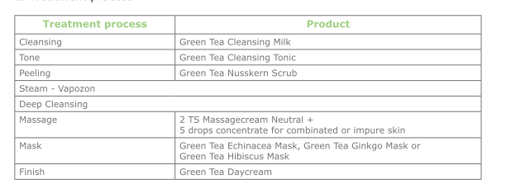

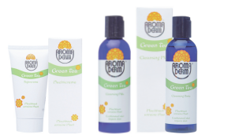
Green Tea Products: Main active ingredient - Green Tea
effect: anti-inflammatory, astringent, rehydrating

Tip:
Use at very red and impure skin the healing earth
mask with a fitting concentrate.

Home care
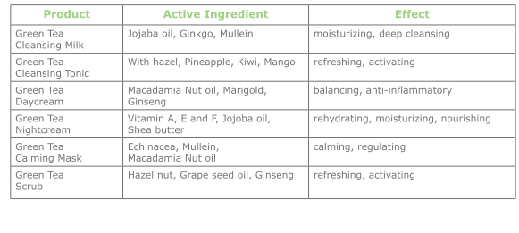
Classic Moisture ~ 90 Min.
Classic Face Treatment for dry skin

Dry and sensible skin: Asiatica products
Effect: calming, moisturizing, tightening

1. Fragrance Ritual: Choose an essential oil
2. Treatment process
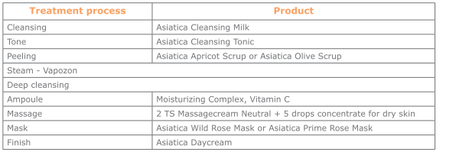
3. Finish Ritual
At the end the customer receives as a gift (give away) - the choosed essential oil.

Asiatica Products: Main active ingredient - Centella Asiatica/Tigergras
effect: rehydrating, tightening, cell-activating
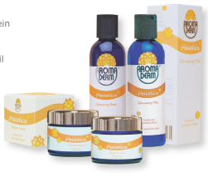
Prime Rose Mask (Cream mask)
effect: rehydrating, tightening, anti-inflammatory
Ingredient: Prime Rose Oil, Shea Butter, Jojoba Oil, Mullein
Wild Rose Mask (Cream mask)
effect: balancing, calming, moisturizing
Ingredient: Aloe Vera, Avocado oil, Marigold, Wild rose oil
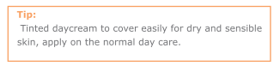

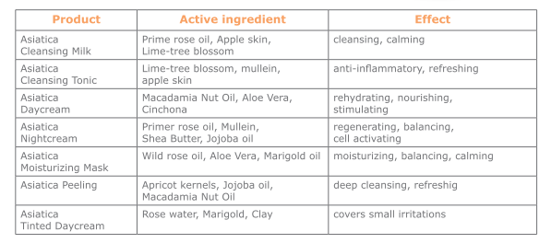

Classic Balance ~ 90 Min.
Classic Face Treatment for impure skin

Combination and impure skin: Green Tea Products
effect: calming, rehydrating, anti-inflammatory

1. Fragrance Ritual: Choose an essential oil
2. Treatment process

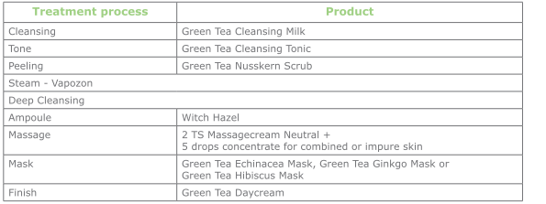

3. Finish Ritual
At the end the customer receives as a gift (give away) - the choose essential oil.
Green Tea products: Main active ingredient - Green Tea
effect: anti-inflammatory, astringent, moisturizing
Echinacea Mask (Cream mask)
effect: anti-inflammatory, moisturizing
ingredients: Cucumber, Mullein, Echinacea, Macadamia Nut Oil
Ginkgo Mask (Cream mask)
effect: refreshing, cleansing, activating
ingredients: Mango, Kiwi, Pineapple, Ginkgo, Marigold Oil
Hibiscus Mask (Gel mask)
effect: balancing, moisturizing
ingredients: Hibiscus, Aloe Vera, Macadamia Nut oil, Vitamin A, E, F
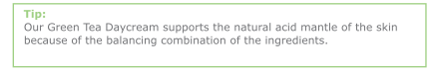
Home care:

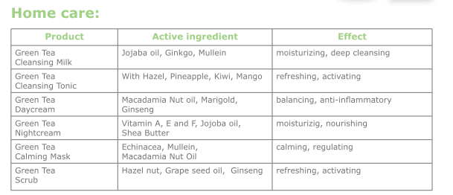
Classic Men ~ 75 Min.
Classic Face Treatment for men

Tired and stressed skin: Thalo Energy Products
effect: vitalizing, refreshing, moisturizing

1. Fragrance Ritual: choose an essential oil
2. Treatment process
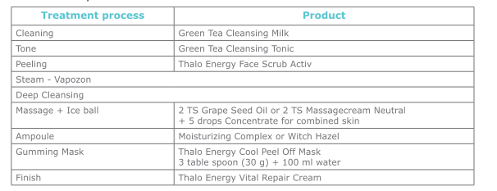

3. Finish Ritual
Thalo Energy Products: Main ingredient - special care out of the sea
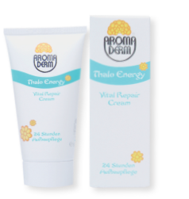
effect: vitalizing, activating
Cool Peel Off Mask (Gumming Mask)
effect: vitalizing, cooling, rebuilding
ingredients: Algae, spirulina, Menthol

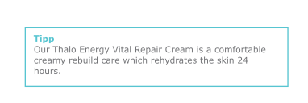

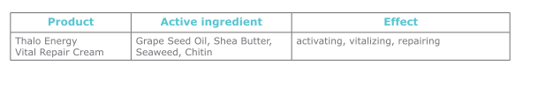
Home Care
Modellage Hydro Intensiv ~ 120 Min. (inclusive consultation)
Intensive - Moisturizing Treatment with Special - Mask

Dry and sensible skin: Asiatica Products + Rosen garden Products
effect: calming, moisturizing, tightening
1. Relax Ritual: Feet washing and choose an essential oil
2. Treatment process

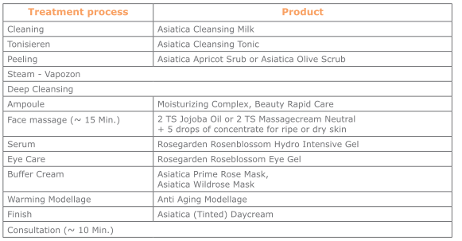
3. Finish Ritual

At the end the customer receives as a gift (give away) - the choosed essential oil.

Asiatica products: Main active ingredient - Centella Asiatica/Tigergras

Rosengarden Products: Main active ingredient - Rose Oil
effect: moisturizing, tightening, cell activating

Prime Rose Mask: (Cream mask)
effect: moisturizing, tightening, balancing
ingredients: Prime Rose Oil, Shea Butter, Jojoba Oil, Mullein

Wild Rose Mask: (Cream mask)
effect: balancing, calming
ingredients: Aloe Vera, Avocado oil, Marigold Oil, Wild rose oil
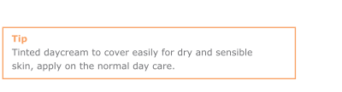
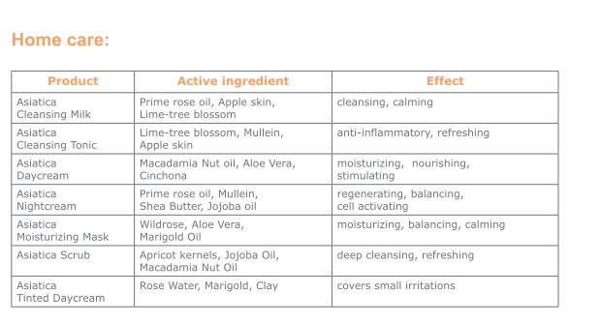
Modellage 35+ ~ 120 Min.
Special Treatment for mature skin

Mature and demanding skin: Anti Aging Products
Effect: thightening, regenerating

Recommend additive treatment for the eyes -Beautiful Eyes

1. Relax Ritual: Feet washing and choose an essential oil
2. Treatment process
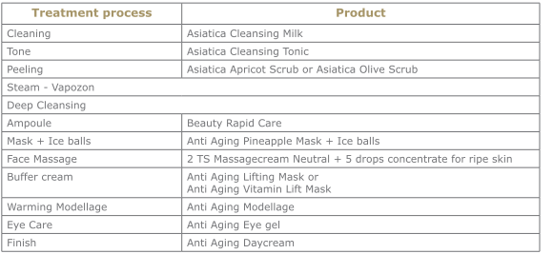

3. Finish Ritual
At the end the customer receives as a gift (give away) - the choose essential oil.

Anti Aging Products: Main active ingredient - Booster Complex
effect: refills the collagen fibre, moisturizing, moisturizing, more fullness of skin
Anti Aging Pineapple Mask (Gel mask)
effect: tightening, moisturizing
ingredient: Avocado oil, Jojoba oil, Pineapple extract
Anti Aging Lifting Mask (Cream mask)
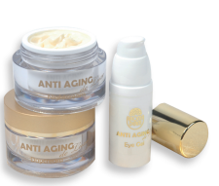
effect: activating, tightening, lifting
ingredient: Tigergras, Ginkgo, wild heath milkwort
Anti Aging Vitamin Lift Mask (Gel mask)
effect: stimulating, activating
ingredient: Tigergras, Seaweed, Vitamin A and E
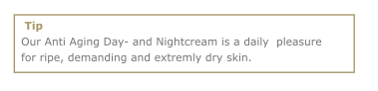

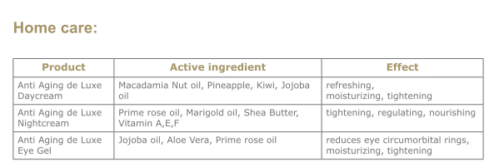

Beauty de Luxe ~ 120 Min.
Rejuvenate Face Treatment with Modellage +
Special Eye Treatment

Mature and demanding skin: Rosengarden Products
effect: cell activating, vitalizing, balancing

1. Relax Ritual: Use a fragrance for the room before the customer enter (Rosengarden woman number one)
+ Feet whasing with Roseblossom Bath salt
2. Bed the customer
3. Treatment process
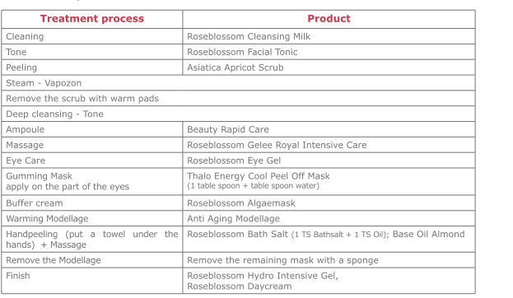
4. Finish Ritual
At the end the customer get a gift with Roseblossom Lip Balm, our Rosegarden folder and samples from the Rosegarden Product Line in a red Organza bad.
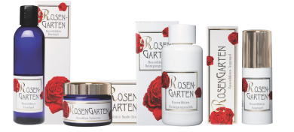

Rosegarden Products: Main active ingredient - Damascena Rose oil and Booster agent
effect: tightening, balancing, rebuilding
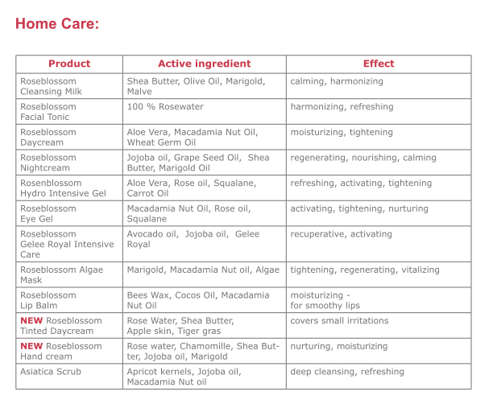
Pure Energy ~ 120 Min.
Face Treatment for tired and stressed skin

Tired and stressed skin: Thalo Energy Products
effect: tightening, moisturizing, activating

1. Relax Ritual: Feet washing and choose an essential oil
2. Treatment process
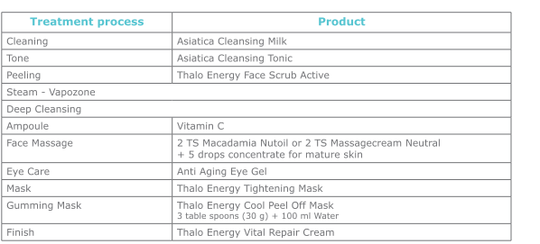

3. Finish Ritual
At the end the customer receives as a gift (give away) - the choose essential oil.

Thalo Energy Products: Main active ingredient - Active ingredients out of the sea
Effect: vitalizing, activating
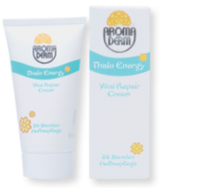
Tightening Mask (Gel mask)
Effect: moisturizing, calming, refreshing
Ingredient: Chitin, Macadamia Nut oil, Aloe Vera

Cool Peel Off Mask (gumming Mask)
Effect: vitalizing, repairing, refreshing
Ingredients: Algae, spirulina, Menthol

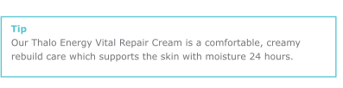
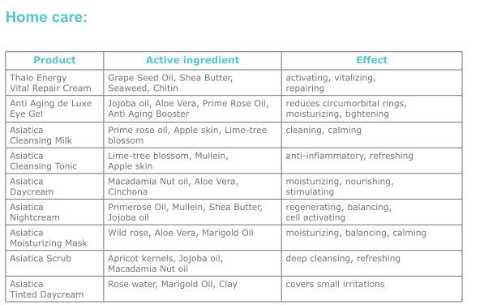
Cacao Pure Power ~ 90 Min.
Power Treatment with Cacao

Tired and weak skin: for face and Dekolleté: Cacao Power
effect: stimulating, moisturizing

1. Relax Ritual: Feet washing and choose an essential oil
2. Treatment process
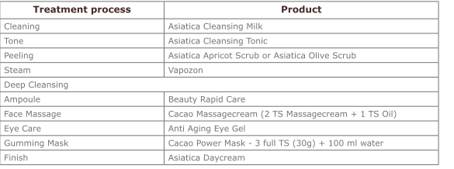
3. Finish Ritual
At the end the customer receives as a gift (give away) - the choose essential oil.

Cacao Power Products: Main active Ingredient - Cacao Butter
effect: activating, very nurturing
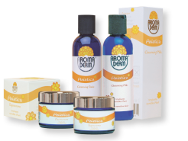
Cacao Power Mask (gumming Mask)
effect: stimulating, cell activating, tightening
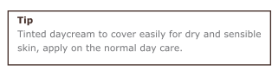
ingredients: cacao powder, Alginate (parts of the Algae)

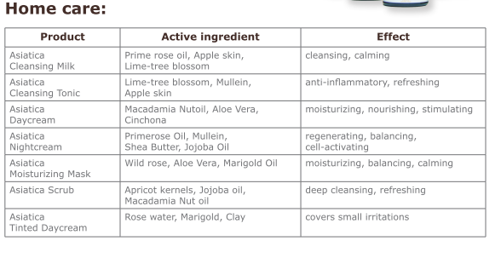
Beautiful Eyes ~ 30 Min.
Special mask for beautiful eyes

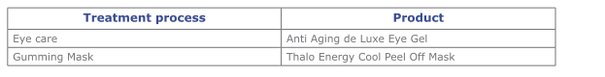
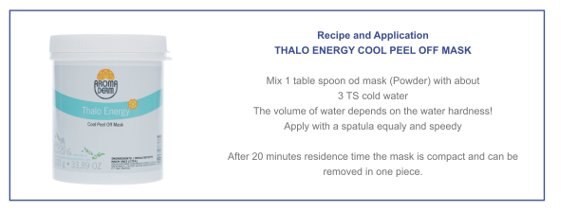
As an addition for the face treatment

Cool Peel Off Mask (gumming mask)
effect: to ebb away, for wrinkles, against circumorbital rings, for
refreshing
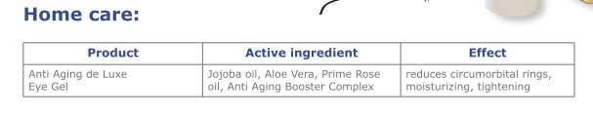
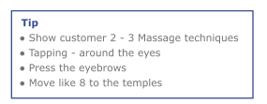
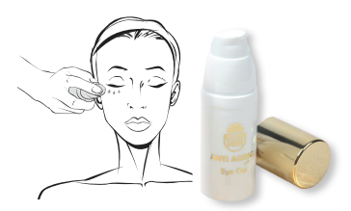
ingredients: Algae, spirulina, Menthol

Push Up ~ 30 Min.
Special Breast Treatment for the breast tightening

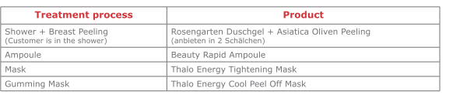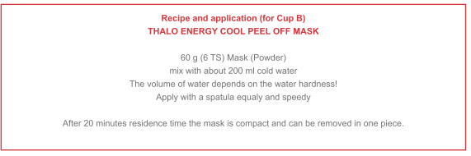

Tightening mask (Gel mask)
effect: moisturizing, tightening, refreshing
ingredients: Chitin, Macadamia Nut Oil, Aloe Vera

Cool Peel Off mask (gumming mask)
effect: vitalizing, repairing, cooling
ingredients: Algae, Spirulina, Menthol

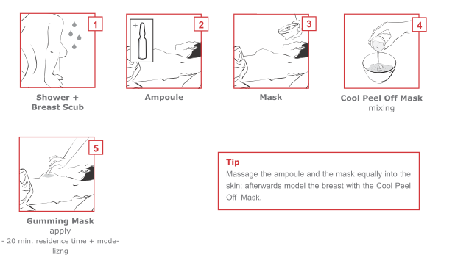
Classic Relax Massage Process
Aroma Derm
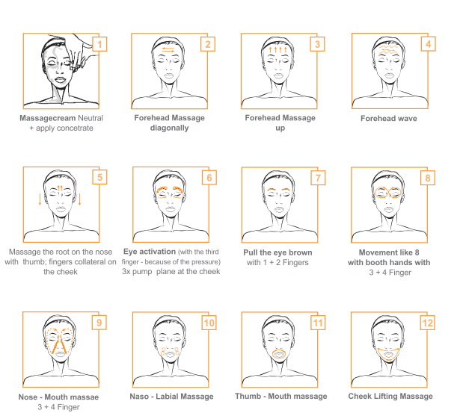
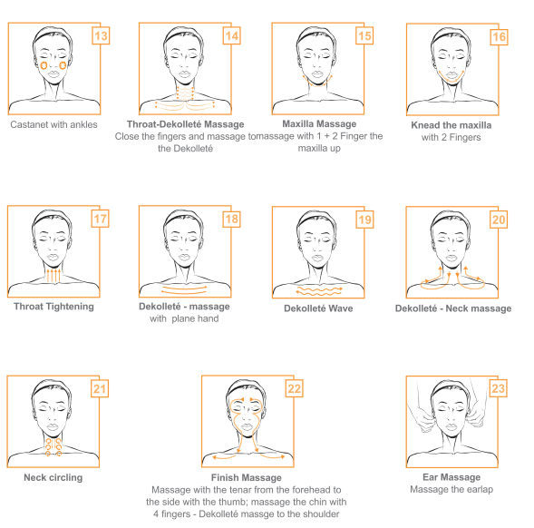
Anti Modellage – working process

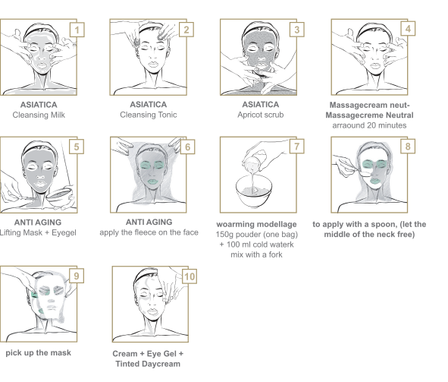

Recipe and using
For each treatment take one bag Anti Aging Modellage with 100 ml cold water, mix it very fast and then apply evenly with a spoon. After 10 minutes the modellage is on its heating top, and then it cools down again. During the cool down the mask gets thick. After 20 minutes the customer can start with small movements of the face, this helps when removing the mask. Take care when you remove the mask, because the eyes are very sensitive to light after this treatment.
The process of the treatment
- Clean with the cleasing milk and tonic
- scrub
- vapozon (vapour)
- deep cleaning
- ampoule
- massage with the massage cream neutral + concentrate for the matured skin + jojoba oil
- Anti Aging lifting mask + apply the eye gel
- apply the fleece - for the face skin protection (make a fly for mouth and nose)
- mix the modellage like in the recipe with a fork mit Gabel
- to apply the modellage with a spoon; the forehead, chin, cheek, cleavage -
please note that the neck has to be free because of difficulty breathing
- 20 minutes waiting that the mask is ready (hard) the costumers should move the skin of the
face (mask can be picked up) the rest you clean with a punk- Anti Aging day cream + eye
gel to finish the treatment
- alternatively or in case you can use the tinted day cream
Gumming mask – working process

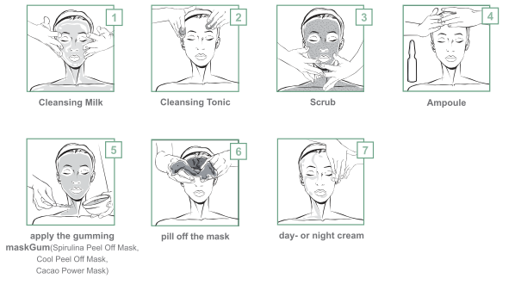

Recipe and using
- 30 g mask (powder, 3 table spoon) mixed with 100 ml cold water
- with the spatula apply evenly and quickly
- 20 minutes application time - then the mask is hard and you can pill of the mask
Treatment process
- cleaning with cleansing milk and tonic
- scrub
- ampoule
- mixing like in the recipe
- apply the modellage with a spoon; the forehead, chin, cheek, cleavage
- 20 minutes waiting that the mask is hard
- pill off the mask, cleaning the rest with a cotton wool pad + cleaning with tonic
- apply the day cream and night cream
Aroma Derm Mask - overview

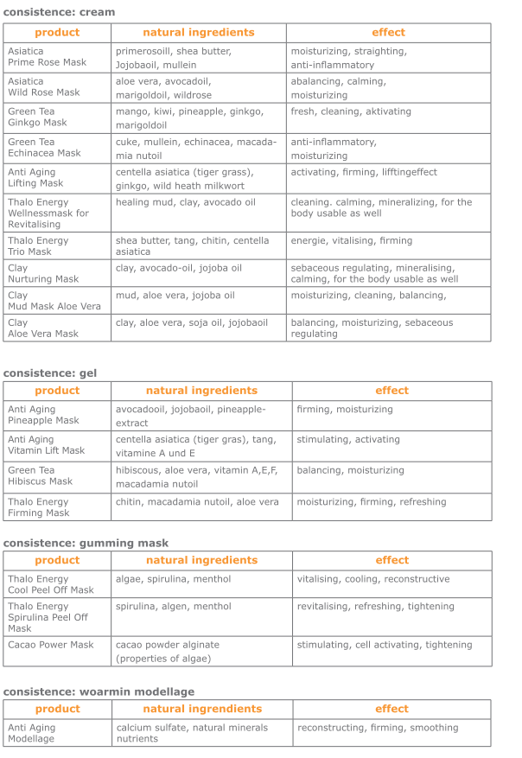
Ampoules

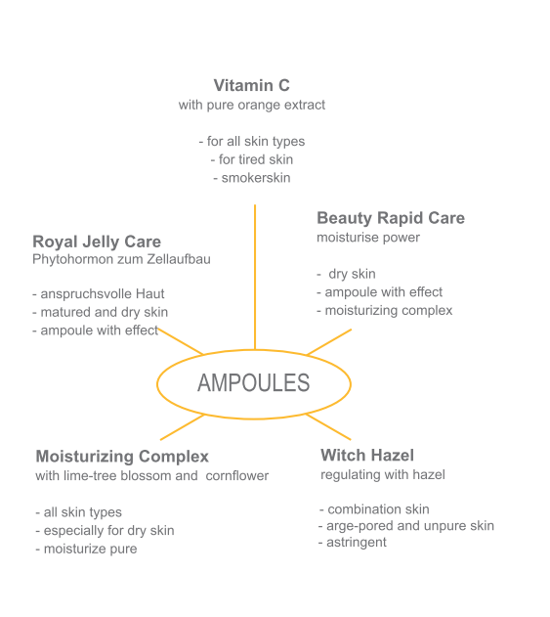

Ampoules

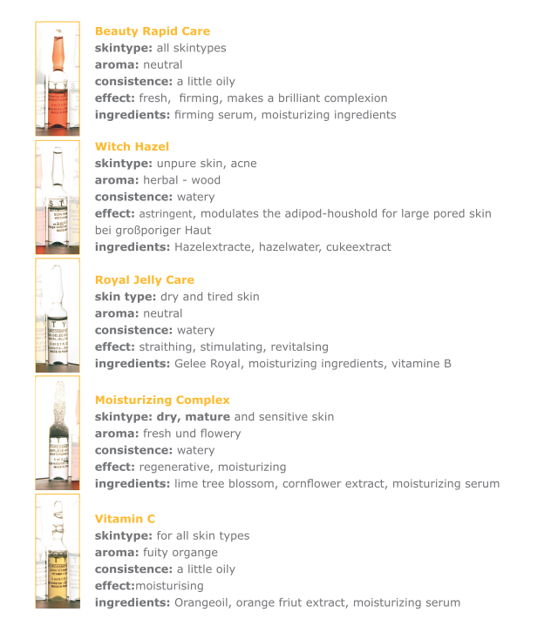
Beauty Rapid Care
skintype: all skintypes
aroma: neutral
consistence: a little oily
effect: fresh, firming, makes a brilliant complexion
ingredients: firming serum, moisturizing ingredients
Witch Hazel
skintype: unpure skin, acne
aroma: herbal - wood
consistence: watery
effect: astringent, modulates the adipod-houshold for large pored skin
bei großporiger Haut
ingredients: Hazelextracte, hazelwater, cukeextract
Royal Jelly Care
skin type: dry and tired skin
aroma: neutral
consistence: watery
effect: straithing, stimulating, revitalsing
ingredients: Gelee Royal, moisturizing ingredients, vitamine B
Moisturizing Complex
skintype: dry, mature and sensitive skin
aroma: fresh und flowery
consistence: watery
effect: regenerative, moisturizing
ingredients: lime tree blossom, cornflower extract, moisturizing serum
Vitamin C
skintype: for all skin types
aroma: fuity organge
consistence: a little oily
effect:moisturising
ingredients: Orangeoil, orange friut extract, moisturizing serum

